**OUTPUT:-**

1.when contact list has contacts it displays the list of all contacts.

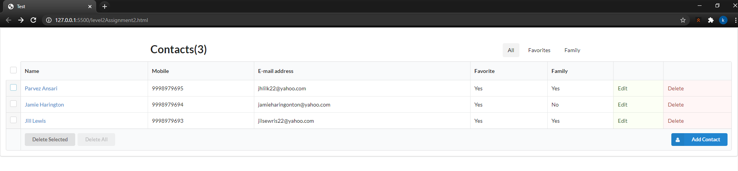

2.view contact on clicking the name

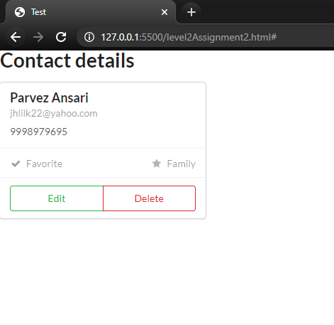

3.When all the contacts are selected it allows delete all

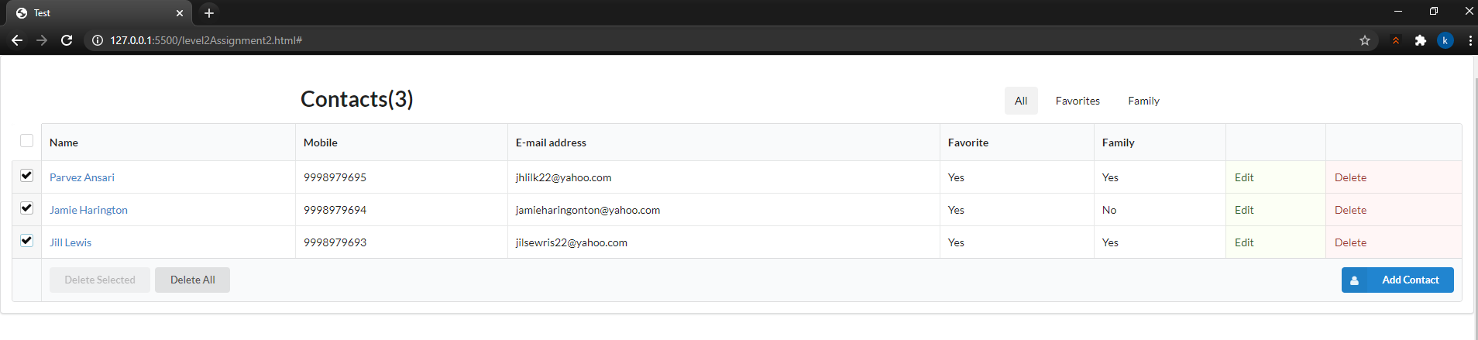

4.click on edit allows to edit the particular contact

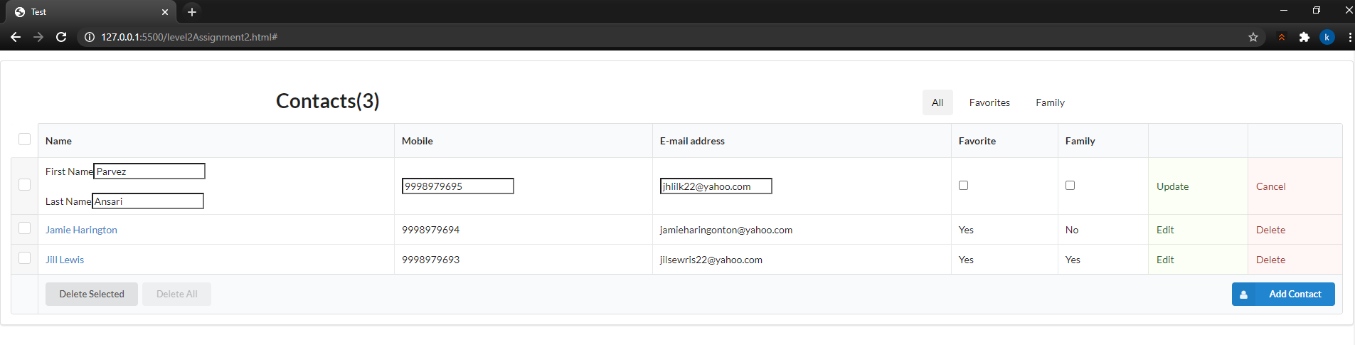

5.click on update save the changes made to the contact.

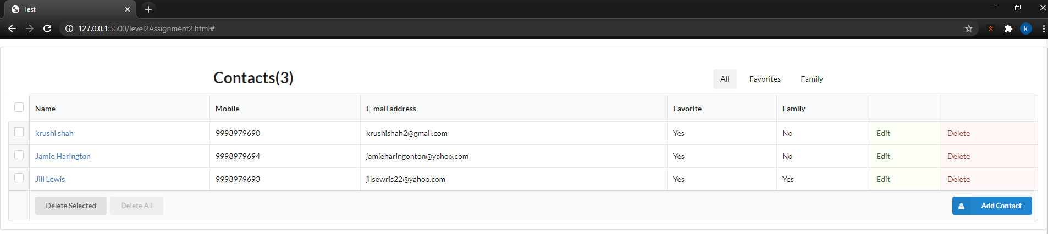

6.click on Delete deletes the contact from the local storage.

Before:

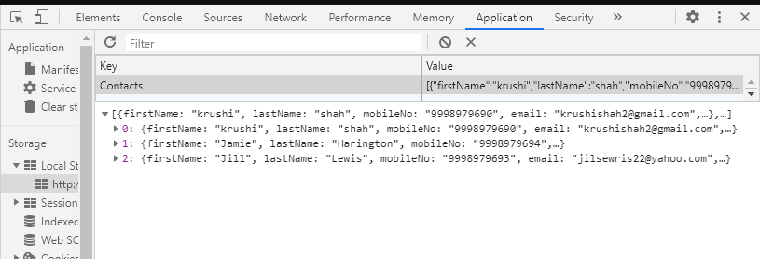

After:

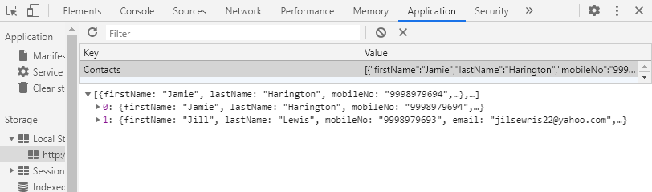

7. Delete all deletes the all contacts.

Before:- 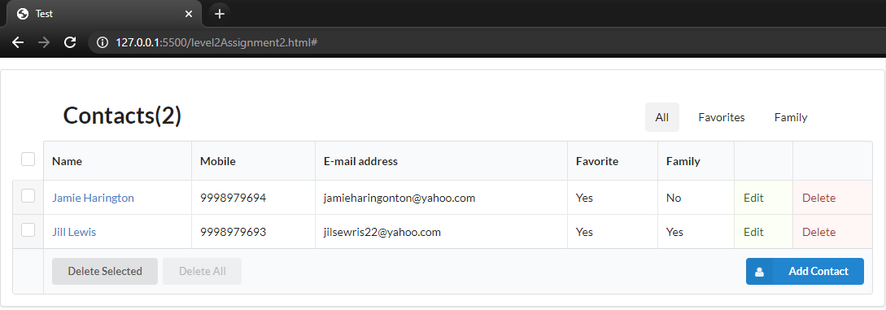

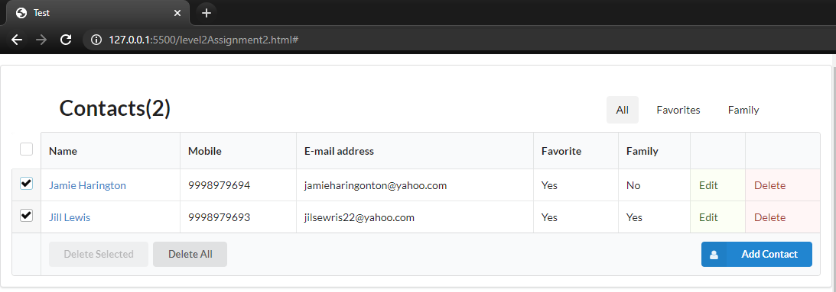

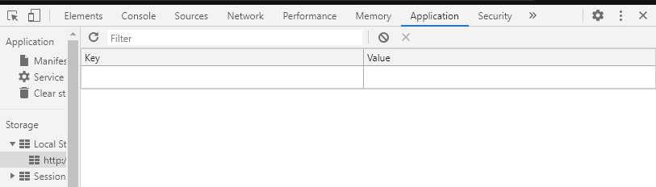

8.If there are zero contacts in the list it displays

